

Phone: 0048 607 659 033  
E-mail: [rafal.siepak@senstation.org](mailto:rafal.siepak@senstation.org)  
Web: www.senstation.org

Your reference Our reference Date **GSBC2013 26.11.2012**

Dear Madam, Dear Sir,

I am honored to have the opportunity to present you the Social Entrepreneurship Network Station and offer possible participation in the Global Social Business Competition.

SENStation is a social media platform inspiring people about social entrepreneurship through sharing positive stories of social entrepreneurs from around the world. It is a place where like-minded people unite to find sustainable solutions to critical real life problems. SENStation facilitates online development of business models through the use of crowd-sourcing elements such as projects, feedback and networking tools.

At the core of SENStation we develop the Global Social Business Competition to foster the development of social entrepreneurship at universities around the world. We bring together various stakeholders, who help students to develop their social ideas: NGOs providing themes, corporations offering funding, coaches developing consulting sessions, academics evaluating projects, social entrepreneurs giving feedback and sharing experiences. All of the stakeholders meet at SENStation.org to help students find innovative solutions to critical problems at the bottom of the pyramid. All the participants are motivated to follow the general rule of the competition expressed in the statement “Bringing SENS to Life”, which means that we support students to carry on most of their projects beyond the competition.

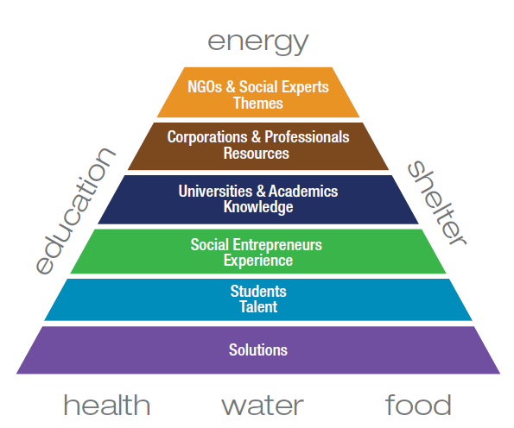

The first competition was organized last year and it brought attention of many students. 17 projects were submitted. They received feedback calls from partnering social entrepreneurs and got evaluated by academics from four CEMS schools in Europe. The group of finalists received coaching and the winner was chosen by Dr. Robert Glasser – Secretary General of CARE International, Nicole Michelbach – Fairtrade International and Prof. Kai Hockerts - representative of the academic panel. The judges have taken into consideration scalability, sustainability and social impact as the main factors determining success of the social business. The winning project – HESSEX - from the University of Sydney will receive the Brave Mind award during the Annual Event in St. Gallen.

Currently the SENStation team is preparing the new edition of the Global Social Business Competition We have received the confirmation of participation from CARE International and Transparency International that have provided the following topics.

* Eradicating poverty through education (by CARE International)
* Promoting transparency and whistleblowing (by Transparency International)
* Creating jobs at the Bottom of the Pyramid (by SENStation)

McKinsey & Company offered their help in coaching the finalists. We also expect many more teams participating this year, since the competition is going to be open to students beyond CEMS.

At SENStation we want to give light to social entrepreneurship talents on the global level. This is possible due to strong support of the CEMS community that helped us to communicate the message to mentioned stakeholders and we are grateful for their constant contribution and strong belief in the project. At the same time we are looking for sponsors that will support our global initiative through the use of their CSR and corporate branding resources. For this reason we have prepared special offer that explains our specific standard value proposition to potential corporate partners. It has to be mentioned that we are flexible in terms of establishing co-operation to create mutual benefits for both parties. We would be more than happy to discuss in details the right approach.   
In case you have any further questions do not hesitate to contact me. It would be my pleasure to answer all of them.

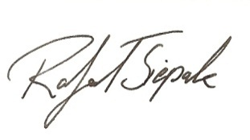Yours faithfully,

CEO&Founder at SENStation